ROYAL OAK INTERNATIONAL SCHOOL
SR. SEC. C.B.S.E. AFFILIATED (2021-22)
PT-II SYLLABUS OF CLASS X

ENGLISH
Reading: Unseen Passage
Writing Skills: Letter to Editor , Enquiry Letter & Story writing
Grammar : Gap Filling, Editing / omission, Sentences reordering
Literature : Prose: L3 : Two Stories about Flying (Part – I & II)
Poem: P3: A Tiger in the Zoo
SR: 2: The thief’s story
HINDI
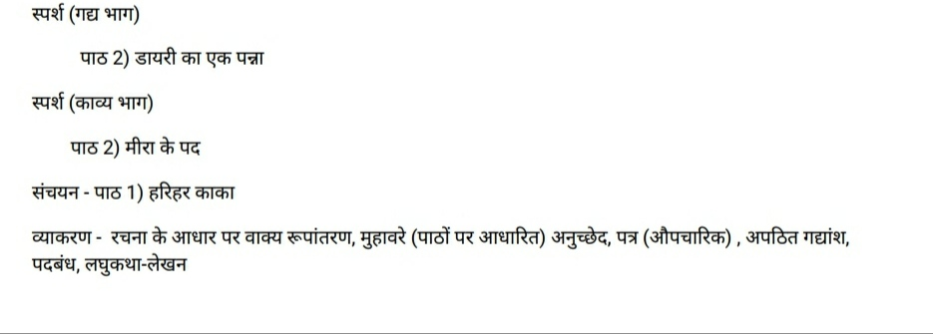
MATHS
Chapter-2
Chapter-4
Chapter-5

SCIENCE
Chemistry:
- Chemical reactions and equations.
- Acids, Bases and Salts
Physics:
- Light (reflection and refraction)
Biology:
- Life process (Complete chapter)

SOCIAL STUDIES

ECO L 2( Sectors of Indian Economy)
HISTORY L 2( Nationalism in India)
INFORMATION TECHNOLOGY
Unit-4: Spreadsheet
Unit-1: Functional English

